**Task 1**

difference between miniconda and anaconda

Differences. There are essentially two main differences: Number of packages: Anaconda comes with over 150 data science packages, whereas miniconda comes with only a handful. Interface: Anaconda has a graphical user interface (GUI) called the Navigator, while miniconda has a command-line interface.

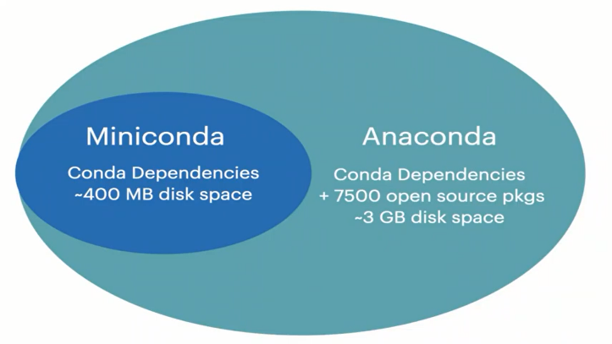

**Task 2**

**Bad code Vs Clean code**

// Bad Code

class CarouselRightArrow extends Component{render(){return ( <a href="#" className="carousel_arrow carousel_arrow--left" onClick={this.props.onClick}> <span className="fa fa-2x fa-angle-left"/> </a> );}};

// Good Code

class CarouselRightArrow extends Component {

render() {

return (

<a

href="#"

className="carousel_arrow carousel_arrow--left"

onClick={this.props.onClick}

>

<span className="fa fa-2x fa-angle-left" />

</a>

);

}

};

**Task 3**

What is a Framework?

Since they are often built, tested, and optimized by several experienced software engineers and programmers, software frameworks are versatile, robust, and efficient.

Using a software framework to develop applications lets you focus on the high-level functionality of the application. This is because any low-level functionality is taken care of by the framework itself.

Why do we use Frameworks?

a framework is a real or conceptual structure intended to serve as a support or guide for the building of something that expands the structure into something useful.

Framework is a container of codes and a system of rules, ideas, or beliefs that is used to plan or decide something.

Collection of libraries.

**Pros**

* Efficiency
* Security
* Expense
* Support

**Cons**

* You learn the framework, not the language
* Restriction
* Code is public

<https://www.youtube.com/watch?v=sXA1zpv4DhA>

**Task 4**

Most popular 5 processors in laptops and 5 in mobiles?

Mobiles

* Bionic
* Qualcomm SnapDragon
* MediaTek
* HisIlicon Kirin
* Samsung Exynos

Processors

* [Intel Core i9-12900KS Processor](https://benchmarks.ul.com/hardware/cpu/Intel+Core+i9-12900KF+Processor+review)

[Intel Core i7-12700K Processor](https://benchmarks.ul.com/hardware/cpu/Intel+Core+i7-12700K+Processor+review)

[AMD Ryzen 9 5950X](https://benchmarks.ul.com/hardware/cpu/AMD+Ryzen+9+5950X+review)

[Intel Core i9-10900K Processor](https://benchmarks.ul.com/hardware/cpu/Intel+Core+i9-10900K+Processor+review)

Intel Core i9-10850K Processor

**Task 5**

How to make recursive code faster than iterative which don't support multi-threading?

**Task 6**

what is hashtables ? why we use hash tables in unordered list?

Hash Table is a data structure which stores data in an associative manner. In a hash table, data is stored in an array format, where each data value has its own unique index value. Access of data becomes very fast if we know the index of the desired data.

Hashing is used for the implementation of programming languages, file systems, pattern search, distributed key-value storage, cryptography, etc. There are a lot of examples where the concept of hashing is used.

Hashtable time complexity = O(1)

<https://www.youtube.com/watch?v=mZFuZHOESEY>

**Task 7**

try:

someFunction()

except Exception as ex:

template = "An exception of type {0} occurred. Arguments:\n"

message = template.format(type(ex).__name__, ex.args)

print message

**Or**

from traceback import print_exc

class CustomException(Exception): pass

try:

raise CustomException("hi")

except Exception as e:

print ('type is:', e.__class__.__name__)

print_exc()

# print("exception happened!")